TABLE OF CONTENTS
1.1 Introduction 2
1.1.1 Types of Users 2
1.2 Registering for a user ID 3
1.2.1 Coordinator Registration 5
1.2.2 User Registration 9
1.3 Secure Connection 13
1.3.1 Making a Secure Connection 13
1.3.2 Your Password 16
1.4 System Administration for Coordinators 19
1.4.1 Establishing yourself as a Coordinator in REMS 20
1.5 Providing a User with System Access 25
1.5.1 Retrieving the User ID 25
1.5.2 User Roles 26
1.5.3 Contract Assignment 29
1.6 Business Partner Relationships 33

LIST OF FIGURES

Figure 1. REAC Home Page 3
Figure 2. Online Systems Screen 4
Figure 3. Need a User ID? screen 4
Figure 4. Registration Form 5
Figure 5. Coordinator Registration Confirmation 7
Figure 6. Registration Accepted for Further Processing. 8
Figure 7. Standard User Registration Confirmation 11
Figure 8. User Registration Accepted for Further Processing 12
Figure 9. Connect to hudapps box 13
Figure 10. Legal Warning 14
Figure 11. Secure Systems – Main Menu 14
Figure 12. PBCA REMS home page 15
Figure 13. Change User Password 17
Figure 14. Reset Password screen 18
Figure 15. Secure Systems – Main Menu 19
Figure 16. User Maintenance Screen 20
Figure 17. Maintain User screen 21
Figure 18. Assign/Unassign Actions for User (1 of 2) 21
Figure 19. Assign/Unassign Actions for User (2 of 2) 22
Figure 20. Successful Transaction box 22
Figure 21. Assign/Unassign Roles for User (1 of 2) 23
Figure 22. Assign/Unassign Roles for User (2 of 2) 24
Figure 23. Assign/Unassign Role Confirmation for User screen 24
Figure 24. User Maintenance Screen 25
Figure 25. User List screen 26
Figure 26. REMS roles 27
Figure 27. Assign/Unassign Role Confirmation for User screen 28
Figure 28. Successful Transaction box 28
Figure 29. Assign/Unassign Role Confirmation for User screen 29
Figure 30. Assistance Contract Assignment Maintenance screen 30
Figure 31: Assign Contract screen 31
Figure 32: Assign Assistance Contract Confirmation screen 32
Figure 33. Business Partners Maintenance 33
Figure 34. Add/Delete Relationships screen 34
Figure 35. Add/Delete Relationships Confirmation screen 34
Figure 36: Business Partners Maintenance screen 35
Figure 37. Active Relationships screen 36

Secure Systems
Objectives:
By the end of this chapter, you will be able to:
- Register for Coordinator and User IDs
- Establish Coordinator Roles
- Provide Users with system access
- Designate system roles for the User

Sensitive information is accessed and transmitted through the HUD website on the Internet. Therefore, a secure environment was developed to ensure that HUD’s information is protected.
An Internet user can access HUD’s system information only after registering for a Coordinator or User’s ID.

Introduction
The purpose of this chapter is to familiarize PBCAs with HUD’s Web-based security software. To protect the integrity, availability, and confidentiality of HUD information, proper security measures were established. For example, a user ID and password are required to access HUD’s secure systems. Potential users can register on-line for a user ID and a password.
Once you receive your user ID, you can access the Secure Systems page, which comprises Multifamily Housing’s systems. The systems allow PBCAs to submit as well as retrieve information from HUD. Authorized PBCAs can access MF Housing systems, which include:
- LOCCS
- REMS
- TRACS Internet Queries

Types of Users
There are two types of Internet users: Coordinators and Users. The Coordinator serves as the PBCAs Executive Director’s representative and performs the administration functions for the secure systems. The Coordinator assigns system rights and roles to each user. A Coordinator is also responsible for forwarding information received electronically from HUD to the PBCA Executive Director.
Although a User can enter or submit data to HUD, they cannot control access to the system. A User depends on the Coordinator for the necessary system rights to enter, view, or submit data.
- Note: The system limits each PBCA to two coordinators. It is recommended that the PBCA Executive Director designate two Coordinators to ensure backup for daily system administration needs.
- Coordinator -Each PBCA must designate a Coordinator, typically an employee, to act as their representative in providing system access to Users. The Coordinator is responsible for retrieving the User’s ID establishing the User’s role in the system.
- User - Unlike a Coordinator, registered Users cannot control system access or perform system maintenance functions. The User must be assigned to a contract and be given the proper roles to add, delete or update data. The User is dependent on the Coordinator for system access as well as updating User information (e.g., email address).

- Note: The term “user” is a generic term for individuals following the instructions of this guide. If “User” (with a capital ‘U’) is discussed, it refers to a specific type of Internet user (User v. Coordinator).

Registering for a user ID
REMS users access HUD-sensitive information over the Internet, therefore, security registration for a user ID is required. An Internet user can access system information only after registering and receiving their user ID, then being assigned system and PBCA data rights.
All Coordinators and Users must submit a completed registration application to HUD to obtain a user ID. The registration requires the applicant’s name, social security number, email address, desired password and mother’s maiden name, as well as, the PBCA’s name and TIN/SSN. The registration form is available online from the REAC web page.
To access the online registration application (for Coordinators and Users):
- Enter the following URL address: www.hud.gov/reac in the Address field from your Internet browser (e.g., Microsoft Internet Explorer). The Real Estate Assessment Center (REAC) home page displays.

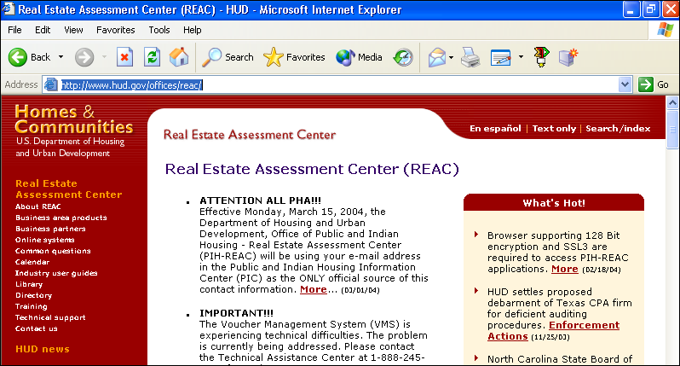
Figure 1. REAC Home Page

- Note: This page is updated on a regular basis, therefore, the appearance may vary.
- On the left side of the screen, click on the Online systems link. The REAC Online Systems screen displays.

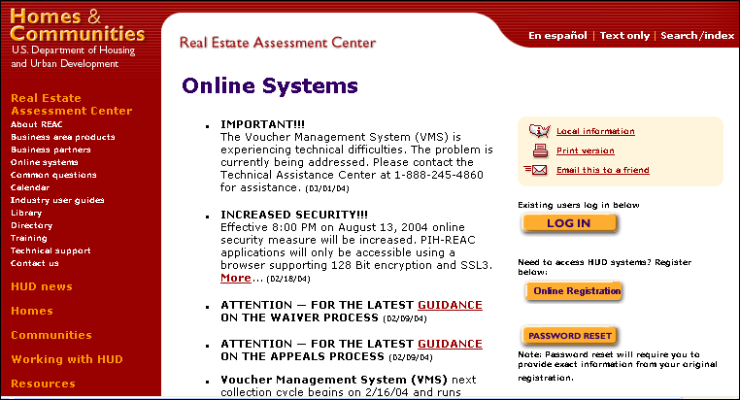
Figure 2. Online Systems Screen

- Click on (Online Registration). The Need a User ID? screen displays.
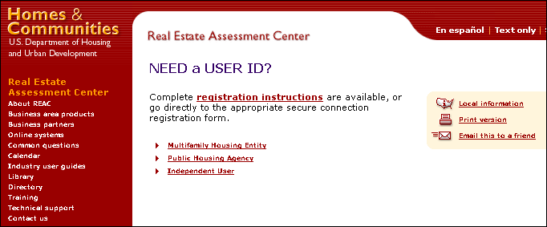
Figure 3. Need a User ID? screen

- Click on the Multifamily Housing Entity link. The Multifamily - Coordinator and User Registration form displays.
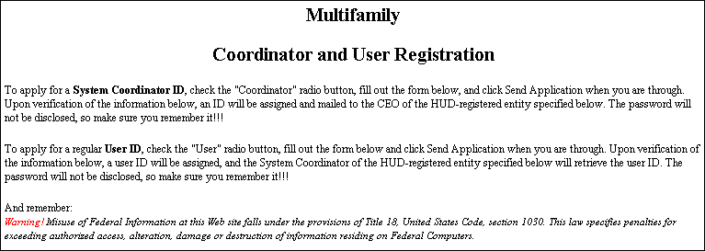
Figure 4. Registration Form

- Note: Except for the middle initial, all fields on this online application are required to receive a Coordinator or User ID.
- Note: The form sections below have been subdivided for instructional purposes.

Coordinator Registration
The Coordinator serves as the PBCAs Executive Director’s representative in controlling access to the system and performing other system administration functions.
To register as a Coordinator:
- On the Multifamily Coordinator and User Registration screen, in the Application Type field, click on the Coordinator radio button.

- Enter the following Coordinator information:
- First Name
- Middle Initial, (optional)
- Last Name
- Social Security Number

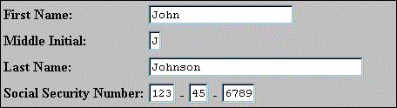
- Note: You can use the Tab key to move from one field to the next.
- Enter the following PBCA information:
- Organization/Individual Name (PBCA’s name)
- TIN/SSN (for PBCA)
- Organization or Individual (select a radio button)

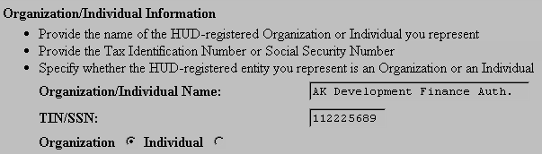
- . Type your email address.
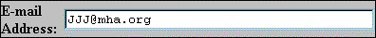
- Enter your password.
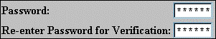
- Your password must be six characters, and can consist of letters and/or numbers.
- Note: Important: Your password is recorded EXACTLY as you type it, so remember how you enter any letters—uppercase or lowercase. Also, this password will be used each time you access HUD’s secure system.
- Enter your Mother’s Maiden Name.
- This information is used for future verification (e.g., if you forget your password).
- Check to ensure that the information in each field is correct.
- Click on the button. A confirmation screen displays.

Alternative Option
To correct a single entry, double-click in the field and enter the correct information.
OR
To clear all the fields, click on , and re-enter all of the information

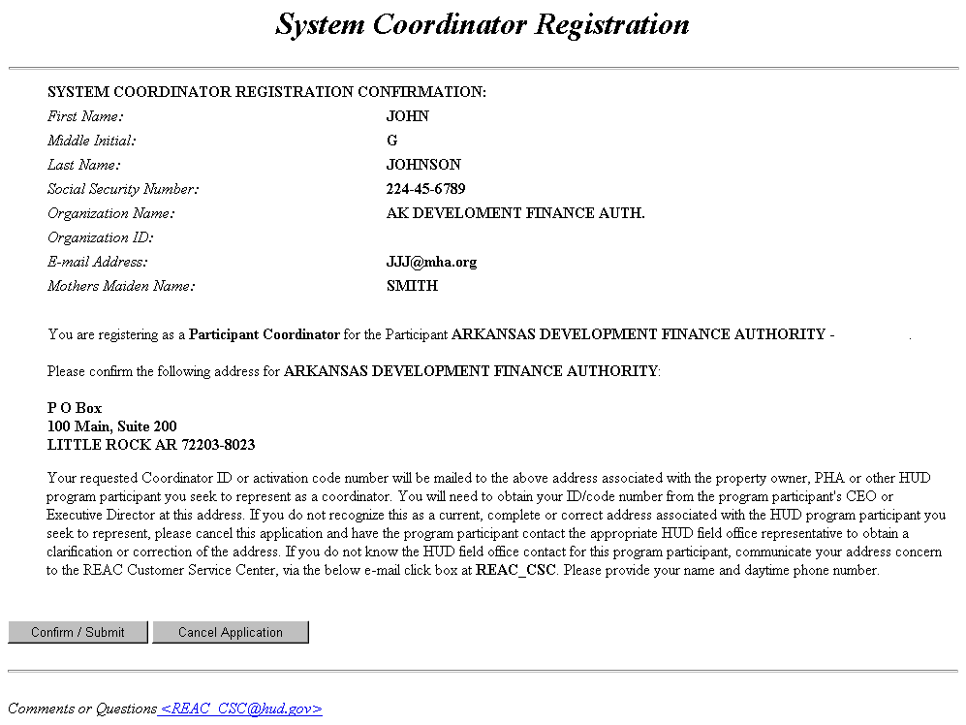
Figure 5. Coordinator Registration Confirmation

- Note: Review all of the information for accuracy, especially the application type, business partner information, and mailing address.
- Note: The mailing address appears only for Coordinators (not Users). Do not proceed with the application if this mailing address is inaccurate or you will not receive your user ID. If the PBCA’s mailing address is incorrect, contact your local HUD field offices to have the information corrected.
- If the information is accurate, click on to submit the application. A screen displays acknowledging acceptance of the registration application for further processing.
OR
Click on , to return to the registration form.

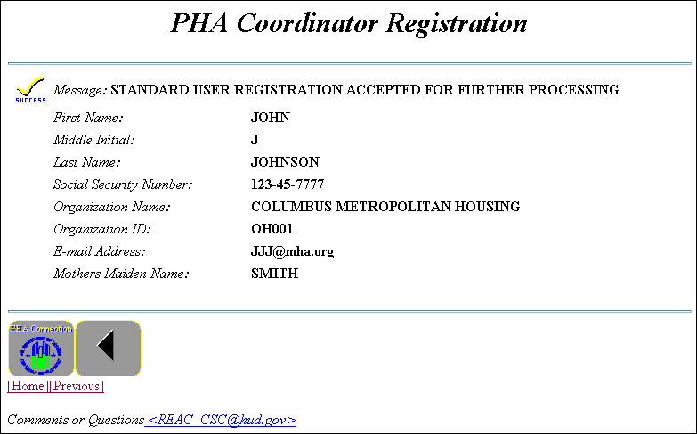
Figure 6. Registration Accepted for Further Processing.

- Note: It is suggested that you print this page for future reference.

To receive your Coordinator ID:
Coordinator registration applications are processed nightly. The PBCA’s information is verified and a user ID is generated. An email notification is sent to the Coordinator to confirm your successful registration.
HUD also sends a letter containing the user ID directly to the PBCA’s Executive Director (to the address that was given on the registration page). This notification is generally sent out the next business day following registration. The PBCA’s Executive Director should receive the letter from HUD within 2 weeks. The Executive Director approves the Coordinator as their representative by providing the Coordinator with their user ID. The letter does not contain your password. You must remember the password you entered on the registration form.

User Registration
A User can be an employee of the PBCA or a third party authorized by the PBCA to submit data for the PBCA.
To register as a User:
- On the Multifamily Coordinator and User Registration screen, in the Application Type field, click on the User radio button.

- Enter the following User information:
- First Name
- Middle Initial (optional)
- Last Name
- Social Security Number

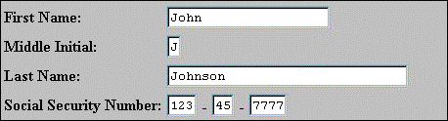
- NOTE: You can use the Tab key to move to the next field.
- Enter the following PBCA information:
- Organization/Individual Name (PBCA’s name)
- TIN/SSN (for PBCA)
- Organization or Individual (select a radio button)

- Note: This must be the TIN for the PBCA of the associated Coordinator.
- Note: You must provide this information to receive your user ID.
4. Type your email address in the E-mail Address field.
- Note: It is important to provide your email address so that HUD can communicate with you.
- Enter your password. Your password must be six characters, and can consist of letters and/or
numbers.

- Your password must be six characters, and can consist of letters and/or numbers.
- Note: Important: Your password is recorded EXACTLY as you type it, so remember how you enter any letters—uppercase or lowercase. Also, this password will be used each time you access HUD’s secure system.
6. Enter your Mother’s Maiden Name. This information is used for future verification (e.g., if you forget your password).
- Check to ensure that the information in each field is correct.
- Note: Review all the information for accuracy, especially the application type and PBCA information.
- Click on to submit the application information. A confirmation page displays.

Alternative Option
To correct a single entry, double-click in the field and enter the correct information.

OR
To clear all the fields, click on, and re-enter all the information.

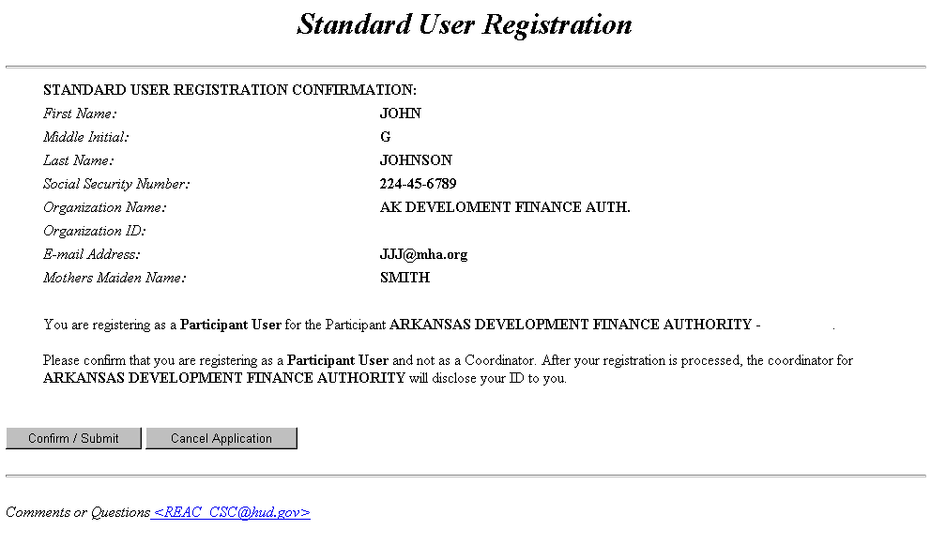
Figure 7. Standard User Registration Confirmation

- If the information is accurate, click on to submit the application.
A screen displays acknowledging acceptance of the registration application for further processing.

OR
Click on , to return to the registration form.

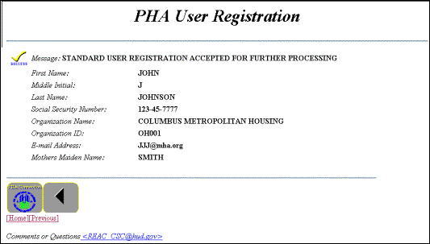
Figure 8. User Registration Accepted for Further Processing
- Note: It is suggested that you print this page for future reference.

To receive your User ID
User registration applications are processed nightly. The PBCA’s information is verified and a user ID is generated.
To obtain their ID, the User must notify the Coordinator that they have registered for a user ID. Allow at least 24 hours after registering for your User ID to be posted. The Coordinator can retrieve the user’s ID from the system and provide this information to the User. A User can access the system after they receive their user ID from the Coordinator and after the Coordinator assign them system rights and roles.

Secure Connection
To make a secure connection to HUD’s secure systems, you must log in with your user ID and password. Because the password is case-sensitive, it must be entered exactly as you requested it on the online registration application. For example, a password entered in lowercase letters during registration must always be entered in lowercase letters upon login to successfully log in to secure systems.

Making a Secure Connection
You can log into secure systems from the Online Systems screen. You can also bookmark the Online Systems screen for quick access to log in.
To access the Secure Systems
- Enter the following URL in the Location field: https://hudapps.hud.gov/HUD_Systems/. The Connect to hudapps.hud.gov box displays.
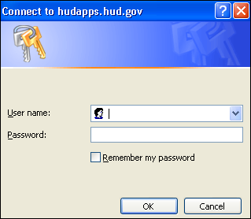
Figure 9. Connect to hudapps box

- Note: Bookmark this site for quick future access.
- Enter your User ID in the User Name field.
- Enter the Password where indicated.
- Note: The User ID will be your M-ID. The User ID must be entered all in uppercase format. Remember your password is case-sensitive.
- Click , and the Legal Warning screen displays.

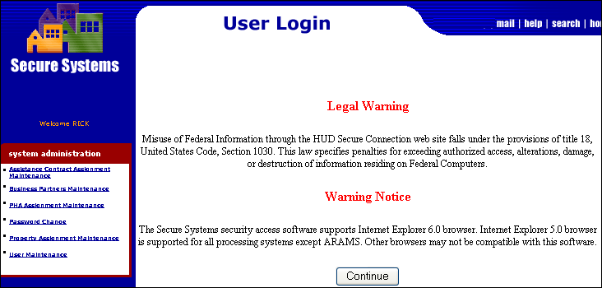
Figure 10. Legal Warning

- Click , and the Secure Systems – Main Menu screen displays.
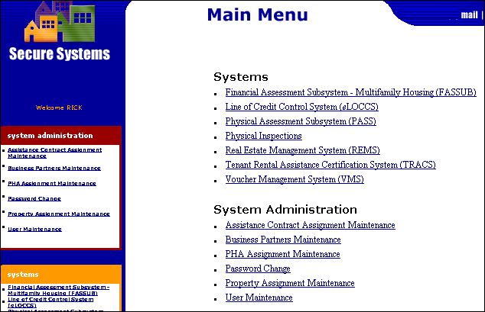
Figure 11. Secure Systems – Main Menu

- Note: For most users, the only link that will appear under “System Administration” is Password Change. The other links appear only for Coordinators.
- Note: A system link does not indicate that you have access to that system. Your Coordinator must assign you rights to REMS before you will be allowed access.

- Click on the Real Estate Management System (REMS) link and the REMS home page displays.

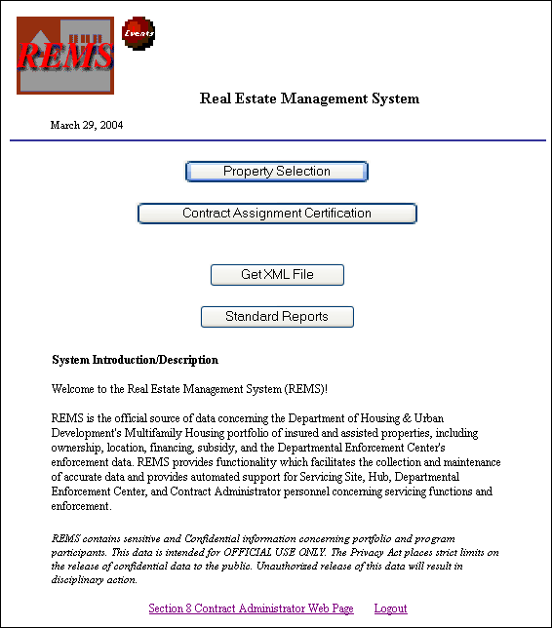
Figure 12. PBCA REMS home page

To exit the Secure Systems web page
You can exit and return to the Secure Systems screen at any time. Because it is a secure system containing sensitive information, you should always exit the system when leaving the computer to ensure that data security is maintained.
- Save any changes on a screen using the appropriate buttons.
- Click on the Close control icon in the top right corner of the screen. The application closes and the desktop displays.

Your Password
Unlike user IDs, User passwords are not accessible to Coordinators. User passwords expire every 21-calendar days. The system automatically prompts you to change your password. You must remember how you saved your new password (i.e., uppercase or lowercase).
If you need to reset your password you must go to the REAC Online Systems screen. If the system does not allow you to reset your password, the Secure Systems Helpdesk will assist you with this process. This will involve security verification of the user’s SSN and mother's maiden name.
For password assistance call the Secure Systems Helpdesk 1-888-245-4860.
- The best contact time is: 7am-9 am or 6pm-8:30pm EST
- The hours of operation are: 7am to 8:30pm EST

To change your password
On the Secure Systems – Main Menu screen, under System Administration, the Password Change option allows Users and Coordinators to change their own passwords.
- From the Secure Systems- Main Menu screen, click on the Password Change link. The Change User Password screen displays:

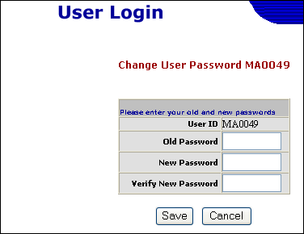
Figure 13. Change User Password

- Enter the following:
- Old Password
- New Password
- Verify New Password (retype New Password exactly as entered)

- Click on . The old password is changed to the new password and the Secure Systems-Main Menu screen displays.
- NOTE: The password change is not instantaneous; it may take up to 15 to 30 minutes to take effect. Your old password is valid until the new password takes effect.

To reset your password
If the system does not allow you to reset your password, after following these instructions, the Secure Systems Helpdesk will assist you with this process.
- Enter the following URL address: www.hud.gov/reac in the Location field from your Internet browser (e.g., Microsoft Internet Explorer). The REAC home page displays.
- On the left side of the screen, click on the Online systems link. The REAC Online Systems screen displays.
- Click on , and the Reset Password screen displays.
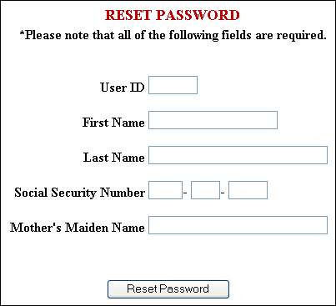
Figure 14. Reset Password screen

- Enter the following:
- User ID
- First Name
- Last Name
- Social Security Number (tab between fields)
- Mother’s Maiden Name

- Note: Password Reset will require you to provide the exact information as entered on the original registration form.
- Click on .

System Administration for Coordinators
As the Coordinator, you perform system administration functions to provide the PBCA User with access to the system and to assign the User rights to the participant’s data. First, you must establish yourself as a Coordinator in the system. Once established as a Coordinator, you can then retrieve IDs, for registered Users, of the entity you represent. A Coordinator can also serve as a User for the PBCA. Therefore, the Coordinator must also be assigned to a specific contract, with the proper role, to enter or edit property data.

Figure 15. Secure Systems – Main Menu

The Secure Systems – Main Menu screen contains two sections: Systems and System Administration. The Systems section provides links to HUD’s secure systems. The list of system links varies based on your rights to the system. Even though the link exists, you must be assigned the proper rights to access the system.
Primarily, the Systems Administration section allows Coordinators to control system access and update User information.

Establishing yourself as a Coordinator in REMS
After registering yourself as a Coordinator, you will receive your user ID from the PBCA Executive Director. Your user ID, along with the password you submitted on your registration application, allows you to log in and set up system rights. In order for the Coordinator to assign roles to other users, the Coordinator must first assign actions and roles to themselves.
After you log in and access the Secure Systems-Main Menu screen, you must establish yourself as a Coordinator in the system in order to perform administrative functions.

To set up Coordinator Actions in REMS:
- On the Secure Systems-Main Menu screen, click on the User Maintenance link. The User Maintenance screen displays.

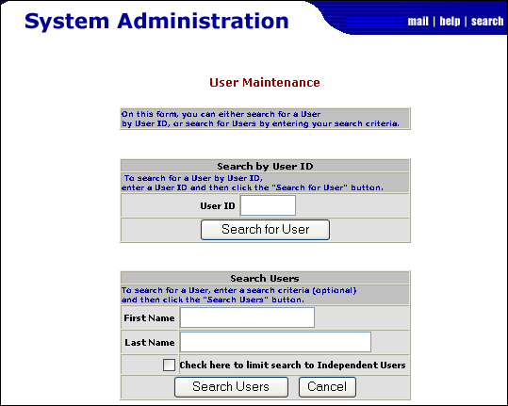
Figure 16. User Maintenance Screen

- Enter your user ID in the User ID field.
- Click on , and the Maintain User screen displays.

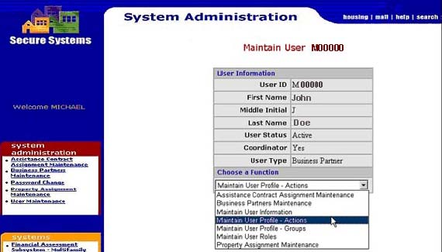
Figure 17. Maintain User screen

- Select Maintain User Profile – Actions from the Choose a Function drop-down list.
- Click on , and the Assign/Unassign Actions for User screen displays.
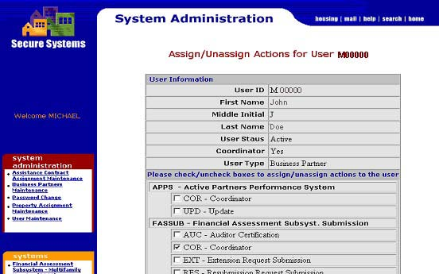
Figure 18. Assign/Unassign Actions for User (1 of 2)

- NOTE: Only Coordinators have access to this screen.
- NOTE: This screen will display several systems in addition to REMS. Your ID only allows you rights to limited systems.
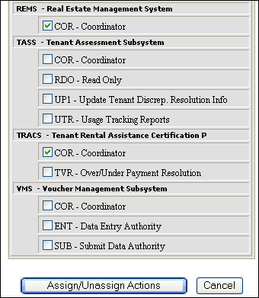
Figure 19. Assign/Unassign Actions for User (2 of 2)

- Click in the checkbox to the left of “COR - Coordinator” under the REMS section.
- Click on , and the “Successful Transaction” dialog box displays.
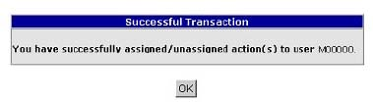
Figure 20. Successful Transaction box

- Click on , to return to the Maintain User screen.

To remove the Coordinator Action in REMS:
On the Secure Systems-Main Menu screen, click on the User Maintenance link. The User Maintenance screen displays.
- Enter the Coordinator’s ID in the User ID field.
- Click on , and the Maintain User screen displays.
- Select Maintain User Profile – Actions from the Choose a Function drop-down list.
- Click on , and the Assign/Unassign Actions for User screen displays.
- NOTE: Only Coordinators have access to this screen.
- NOTE: This screen will display several systems in addition to REMS. Your ID only allows you rights to select systems.
- Click in the box to the left of “COR - Coordinator” under the REMS section, to remove existing check mark.
- Click on , and the “Successful Transaction” dialog box displays.
- Click on , to complete the process and return to the Maintain User screen.

To set up Coordinator Roles in REMS:
- On the Secure Systems-Main Menu screen, click on the User Maintenance link. The User Maintenance screen displays.
- Enter the Coordinator’s ID in the User ID field.
- Click on , and the Maintain User screen displays.
- Select Maintain User Roles from the Choose a Function drop-down list.
- Click on , and the Assign/Unassign Roles for User screen displays.

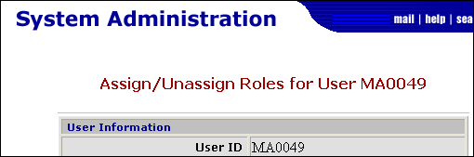
Figure 21. Assign/Unassign Roles for User (1 of 2)
- Note: This screen will display several systems in addition to REMS. Your ID only allows you rights to select systems.
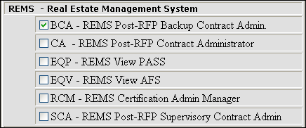
Figure 22. Assign/Unassign Roles for User (2 of 2)
- Click in the box to the left of the appropriate Coordinator role (BCA, CA, or SCA) under the REMS section.
- Note: Although other roles appear in the table, the only roles available for PBCA users are: Contract Administrator (CA); Backup Contract Administrator (BCA); and Supervisory Contract Administrator (SCA). All roles have the same level of accessibility.
- Click on , and the Assign/Unassign Role Confirmation screen displays.
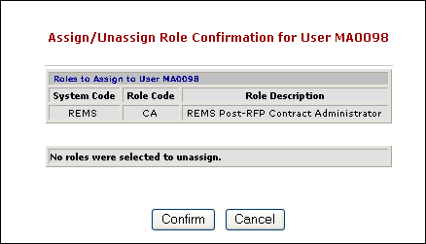
Figure 23. Assign/Unassign Role Confirmation for User screen

- Click on to accept changes, and the “Successful Transaction” dialog box displays.
- Click on , to complete the process and return to the Maintain User screen.

Providing a User with System Access
As the PBCA’s Coordinator, you are responsible for controlling access to the system and the PBCA data. You should verify that a User is authorized to do business for the PBCA prior to allowing the User access to the system on their behalf.
The Coordinator must then assign a User a system role and rights to the PBCA’s data.

Retrieving the User ID
After a User has registered with HUD and notified you (the Coordinator) of their registration, you must retrieve the user ID from the system. Registration applications are processed nightly, so allow at least 24 hours after a User has registered before attempting to retrieve their ID.
To retrieve a user ID for a User:
- On the Secure Systems-Main Menu screen, click on the User Maintenance link. The User Maintenance screen displays.
Figure 24. User Maintenance Screen
- Enter the User’s First and Last Name in the appropriate field (for an individual search).
OR
Leave First and Last Name fields blank for a comprehensive (group search) of all users.
- Click on , and the User List screen displays the user ID and other relative information.
Jones
778577734566987
Linda
Figure 25. User List screen
- Click on the User ID link and the Maintain User screen displays.

User Roles
After retrieving the User’s ID, the Coordinator must assign a role that allows the user update rights.
To assign a system role to a User:
- On the Secure Systems-Main Menu screen, click on the User Maintenance link. The User Maintenance screen displays.
- Enter the User’s ID in the User ID field.
- Click on , and the Maintain User screen displays.
- Select Maintain User Roles from the Choose a Function drop-down list.
- Click on , and the Assign/Unassign Roles for User screen displays.
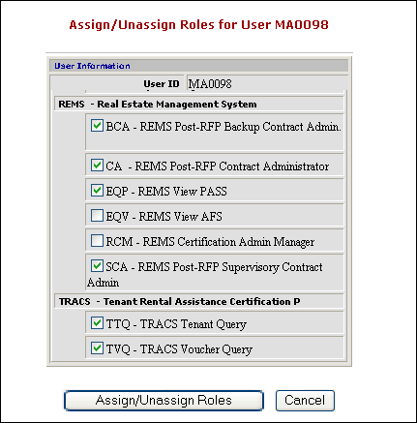
Figure 26. REMS roles
- Note: The Coordinator only sees the roles for the system(s) he or she identified in the Maintain User Profile – Actions function. For example, if you serve as Coordinator for REMS, the REMS roles will display for assignment purposes.
- Click in the box to the left of desired role under the REMS section.
- Note: There are 3 roles available in REMS that allow Users to input data on assigned contracts: CA - REMS Post-RFP Contract Administrator; SCA - REMS Post-RFP Supervisory Contract Admin; and BCA - REMS Post-RFP Backup Contract Admin
- Click , and the Assign/Unassign Role Confirmation screen displays.
Figure 27. Assign/Unassign Role Confirmation for User screen

- Click on to accept changes, and the “Successful Transaction” dialog box displays.
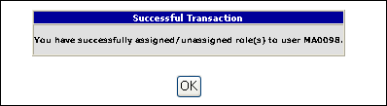
Figure 28. Successful Transaction box
- Click on , to complete the process and return to the Maintain User screen.

To unassign a system role for a User:
- On the Secure Systems-Main Menu screen, click on the User Maintenance link. The User Maintenance screen displays.
- Enter the User’s ID in the User ID field.
- Click on , and the Maintain User screen displays.
- Select Maintain User Roles from the Choose a Function drop-down list.
- Click on , and the Assign/Unassign Roles for User screen displays.
- Click in the checkbox to the left of the role you want to unassign under the REMS section.
- Click on , and the Assign/Unassign Role Confirmation for User screen displays.
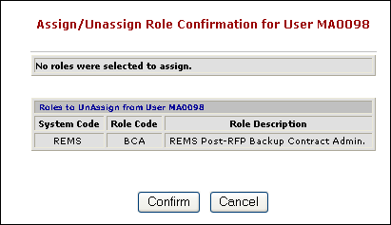
Figure 29. Assign/Unassign Role Confirmation for User screen

- Click on , to accept changes, and the “Successful Transaction” dialog box displays.
- Click on , and you will be returned to the Maintain User screen.

Contract Assignment
The Coordinator uses the Assistant Contract Assignment Maintenance function to establish User rights to specific contracts. The Coordinator will only have access the contracts that are assigned to the Business Partner he or she represents.
To assign Contract rights to a User:
- On the Secure Systems-Main Menu screen, click on the Assistant Contract Assignment Maintenance link. The Assistant Contract Assignment Maintenance screen displays.
- Enter the User ID in the User ID field.
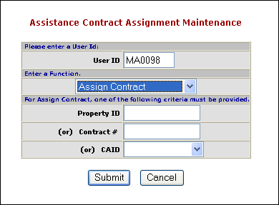
Figure 30. Assistance Contract Assignment Maintenance screen

- Select Assign Contract from the Enter a Function drop-down list.
- Select the appropriate Contract Administrator ID from the CAID drop-down list.
- Note: Searching by the Property ID or the Contract # will yield on the one property. A search using the CAID will provide a list of all contract assigned to your PBCA and allow you to perform multiple assignments for one user.
- Click on , and the Assign Contract screen displays.
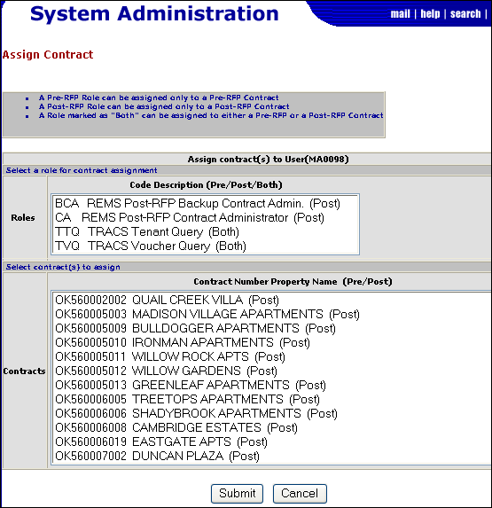
Figure 31: Assign Contract screen
- Note: The screen displays all the Roles assigned to the user and the contracts requested by your selection criteria. (Only contracts assigned to your PBCA or Business Partner will display).
- Highlight the desired role or roles from the Roles selection box.
- Highlight the desired contract or contracts from the Contracts selection box.
- Note: To select multiple contracts, hold down the Ctrl key when making each selection. To select a consecutive group of contracts, highlight the first contract then place your cursor on the last contract, then hold down the SHIFT key to highlight the row.
- Click on , and the Assign Assistance Contract Confirmation screen displays.
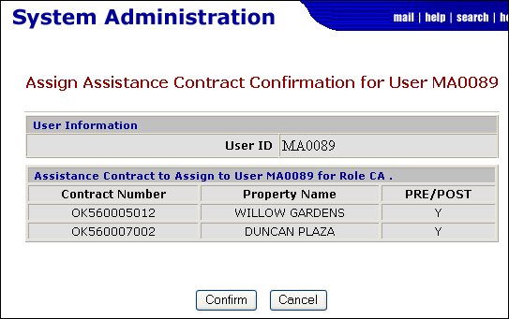
Figure 32: Assign Assistance Contract Confirmation screen

- Click on to accept changes, and the “Successful Transaction” dialog box displays.

Business Partner Relationships

The first Coordinator relationship with a Business Partner (PBCA for REMS) is an “original” relationship and is established during the initial coordinator registration process. Coordinators may request relationships with multiple Business Partners (BPR). The Coordinator must establish this BPR in secure systems via the Business Partner Maintenance modules.
To request/establish additional Business Partner Relationships:
- On the Secure Systems-Main Menu screen, click on Business Partners Maintenance link. The Business Partners Maintenance screen displays.
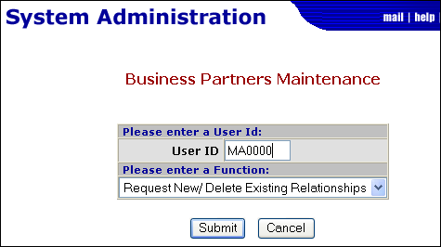
Figure 33. Business Partners Maintenance

- Enter the User ID in the User ID field.
- Select Request New/Delete Exiting Relationships from the Enter a Function drop-down list.
- Click on , and the Add/Delete Relationships screen displays.
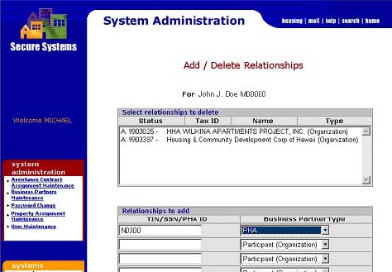
Figure 34. Add/Delete Relationships screen

- In the “Relationships to add” section, enter the Business Partner’s TIN/SSN and select the Business Partner type from the drop-down list.
- Click on , and the Add/Delete Relationships Confirmation screen displays.

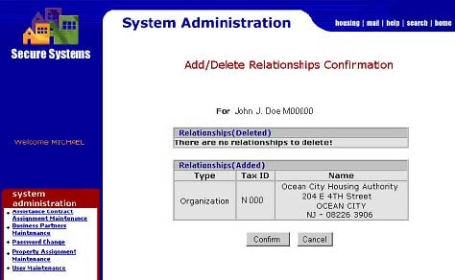
Figure 35. Add/Delete Relationships Confirmation screen

- Note: Make sure to verify the accuracy of the Business Partner’s mailing address. The Activation Key (which will be needed to complete this process) will be mailed to the address shown.
- Click on , to accept the information, and the “Successful Transaction” dialog box displays.

To activate the Business Partner relationship:
The Coordinator’s request for a new BP relationship will trigger a letter to be sent to the Business Partner with an Activation Key to confirm the relationship. Once the Coordinator has received the Activation Key from the Business Partner, he/she must activate the relationship in Secure Systems.
- On the Secure Systems-Main Menu screen, click on Business Partners Maintenance link. The Business Partners Maintenance screen displays.
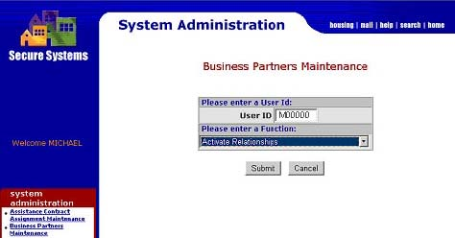
Figure 36: Business Partners Maintenance screen

- Select Activate Relationships from the Enter a Function drop-down list.
- Click on , and the Activate Relationships screen displays.
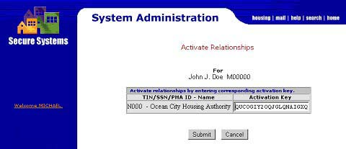
Figure 37. Active Relationships screen

- Enter the corresponding Activation Key in the space provided.
- Note: The Coordinator must obtain the Activation Key from the Business Partner.
- Click on , and the “Successful Transaction” dialog box displays.

Notes:

