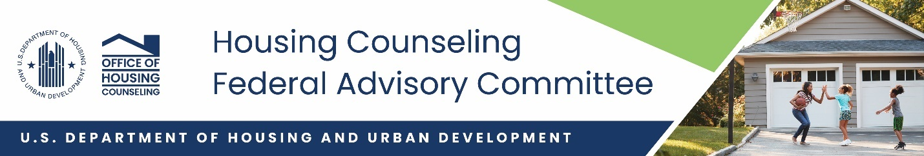

**Impact of the Housing Counseling Federal Advisory Committee**

**FY 2022-FY 2024**

After a period of inaction, by January 2022, the Housing Counseling Federal Advisory Committee (HCAC) had full membership. The twelve members were enthusiastic to start their work of providing advice to Office of Housing Counseling (OHC) regarding the carrying out of its mission to help consumers assess their financial situation and achieve their housing goals.

**Membership**

After rigorous selection process, the full HCFC was appointed. The twelve members equally represent equally represent the mortgage and real estate industry, including consumers and housing counseling agencies approved by the Secretary. During this period, two members were replaced as they had to resign from the HCFAC. The members were appointed for terms of 3 years.

As all the terms expire in January 2025, OHC has solicitated applications for the HCFAC. New member will be appointed the fall of 2024.

OHC is working to re-establish staggered terms.

Members FY2022-2024

* Ibijoke Akinbowale
* Lawrence Batiste
* Carol Ann Dujanovich,
* Marcia Lewis, (deceased)
* Bill Sevilla
* Tony Walters,
* Patricia Arvielo (resigned)
* Paul Yorkis,
* Gabe Del Rio
* Daniel Garcia
* Angie Liou
* Richard Verrillo
* Sherri Eckles

**Meetings**

Since January 2022, the HCFAC has held 11 meetings on a wide range of topics, including regular updates on HUD and OHC policies and programs. The many topics included:

* Housing Counseling Program Modernization
* Improving Delivery of Housing Counseling Services
* Disaster response and recovery
* Aging in Place - an Update on Reserve Mortgages
* OHC marketing campaign
* Tribal Counselor Certification Rule
* Asian Americans, Native Hawaiian & Pacific Islanders (AANHPI)-Trends in Housing and Community Development
* Homelessness
* Challenges in Latino housing
* PAVE

Recordings of the meetings can be found at [Housing Counseling Federal Advisory Committee | HUD.gov / U.S. Department of Housing and Urban Development (HUD)](https://www.hud.gov/program_offices/housing/sfh/hcc/housing_counseling_federal_advisory_committee).

In an exciting move after the Pandemic, we began to have in-person meetings in locations that were appropriate for the subject of the meeting.

The June 2023 meeting was at the Japanese American National Museum in Los Angeles, CA. The meeting reinforced HUD’s ongoing efforts to reach deeper into Asian American, Native Hawaiian, and Pacific Islander (AANHPI) communities through housing counseling services that are responsive to their cultural practices, preferred languages, and communication needs. The members took a tour of the Asian American communities. This was the first HCFAC meeting to be held outside HUD’s Headquarters in Washington, DC, in at least five years.

The HCFAC met in San Antonio, TX in March 2024, to collaborate, share insights, and provide recommendations on HUD’s Housing Counseling Program. The meeting focused on the Latiné community’s unique challenges and explored strategies to enhance access to affordable housing and related services. While in San Antonio, HCFAC members and HUD’s OHC team toured several organizations and learned about their initiatives for addressing housing challenges faced by the Latiné community.

**Member Discussions**

During all 11 HCFAC meeting, the members participated in robust Q&A sessions and discussions with the presenters of the various sessions. OHC management used the input and observations from the members when considering new policies and procedures.

The minutes are available at [Housing Counseling Federal Advisory Committee | HUD.gov / U.S. Department of Housing and Urban Development (HUD)](https://www.hud.gov/program_offices/housing/sfh/hcc/housing_counseling_federal_advisory_committee).

**Member Recommendations**

The member discussions resulted in several recommendations to OHC regarding the accomplishment of its mission to provide individuals and families with the knowledge they need to obtain, sustain, and improve their housing.

* OHC should continue efforts to modernization the housing counseling program to improve the delivery of services, including possible revisions to the regulations
* Encourage collaborative effort between the housing counseling agencies, local housing organization such government agencies, real estate agents, banks/lenders, and non-profits solving some of the gaps in wealth and home ownership.
* Educate housing counselors about Special Credit Programs so that they can include them as an important tool for clients.
* Work with Single Family Housing to develop data and policies for ITIN mortgages.
* Make marketing materials and campaign easily available and understandable to housing counseling agencies and their clients, using multiple media tools and mediums.
* Study the homeownership gap in every market and look at from a racial and ethnic perspective.
* Continue to work with CPD to include housing counseling in the CCBG-DR program.
* Prepare a study on the housing needs of the elderly, considering financial and cultural issues, including a study of the impact of age on delivery on counseling services.
* Expand workforce programs for housing counselors to include junior colleges.
* Support coordination and sharing homeless resources and planning.
* Continue to improve direct communication between OHC, housing counselors, and housing counseling agencies.
* Work with Single Family on issues such as complicate titles, contract for deed mortgages, intergenerational households and income that's not traditionally included in qualifying in the mortgage model that exists now. loss mitigation tools for ways to restructure to make saving the home from foreclosure, etc.
* Work with Single Family Housing and ONAP to examine significant variations in land tenure among tribes, impacting housing efforts.